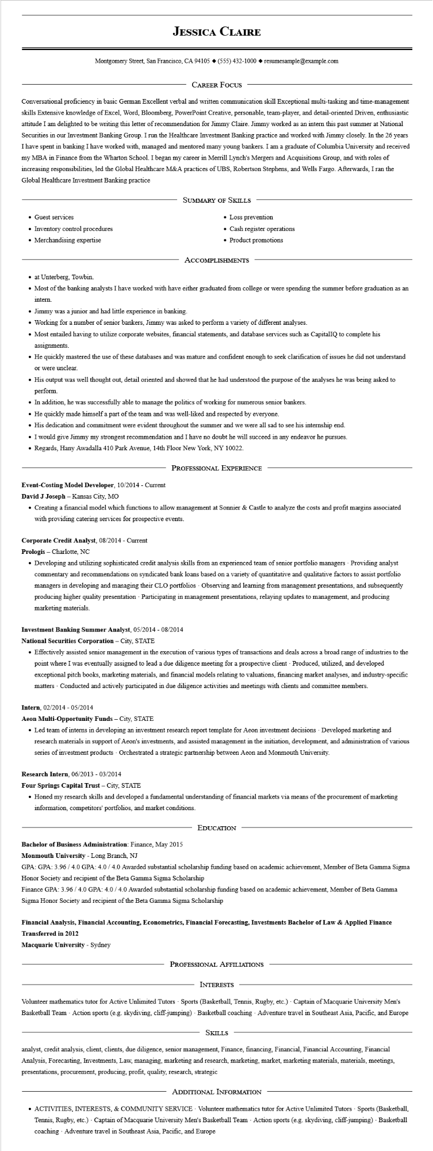
JESSICA CLAIRE
Montgomery Street, San Francisco, CA 94105 ♦ (555) 432-1000 resumesample@example.com
CAREER FOCUS
Conversational proficiency in basic German Excellent verbal and written communication skill Exceptional multi-tasking and time-management skills Extensive knowledge of Excel, Word, Bloomberg, PowerPoint Creative, personable, team-player, and detail-oriented Driven, enthusiastic attitude I am delighted to be writing this letter of recommendation for Jimmy Claire. Jimmy worked as an intern this past summer at National Securities in our Investment Banking Group. I run the Healthcare Investment Banking practice and worked with Jimmy closely. In the 26 years I have spent in banking I have worked with, managed and mentored many young bankers. I am a graduate of Columbia University and received my MBA in Finance from the Wharton School. I began my career in Merrill Lynch's Mergers and Acquisitions Group, and with roles of increasing responsibilities, led the Global Healthcare M&A practices of UBS, Robertson Stephens, and Wells Fargo. Afterwards, I ran the Global Healthcare Investment Banking practice
• Guest services
• Inventory control procedures
• Merchandising expertise
SUMMARY OF SKILLS
• Loss prevention
• Cash register operations
• Product promotions
ACCOMPLISHMENTS
⚫ at Unterberg, Towbin.
• Most of the banking analysts I have worked with have either graduated from college or were spending the summer before graduation as an intern.
• Jimmy was a junior and had little experience in banking.
• Working for a number of senior bankers, Jimmy was asked to perform a variety of different analyses.
• Most entailed having to utilize corporate websites, financial statements, and database services such as CapitalIQ to complete his assignments.
• He quickly mastered the use of these databases and was mature and confident enough to seek clarification of issues he did not understand or were unclear.
• His output was well thought out, detail oriented and showed that he had understood the purpose of the analyses he was being asked to perform.
• In addition, he was successfully able to manage the politics of working for numerous senior bankers.
• He quickly made himself a part of the team and was well-liked and respected by everyone.
• His dedication and commitment were evident throughout the summer and we were all sad to see his internship end.
⚫ I would give Jimmy my strongest recommendation and I have no doubt he will succeed in any endeavor he pursues.
• Regards, Hany Awadalla 410 Park Avenue, 14th Floor New York, NY 10022.
PROFESSIONAL EXPERIENCE
Event-Costing Model Developer, 10/2014 - Current
David J Joseph - Kansas City, MO
• Creating a financial model which functions to allow management at Sonnier & Castle to analyze the costs and profit margins associated with providing catering services for prospective events.
Corporate Credit Analyst, 08/2014 - Current
Prologis - Charlotte, NC
• Developing and utilizing sophisticated credit analysis skills from an experienced team of senior portfolio managers Providing analyst commentary and recommendations on syndicated bank loans based on a variety of quantitative and qualitative factors to assist portfolio managers in developing and managing their CLO portfolios Observing and learning from management presentations, and subsequently producing higher quality presentation Participating in management presentations, relaying updates to management, and producing marketing materials.
Investment Banking Summer Analyst, 05/2014 - 08/2014
National Securities Corporation - City, STATE
• Effectively assisted senior management in the execution of various types of transactions and deals across a broad range of industries to the point where I was eventually assigned to lead a due diligence meeting for a prospective client - Produced, utilized, and developed exceptional pitch books, marketing materials, and financial models relating to valuations, financing market analyses, and industry-specific matters - Conducted and actively participated in due diligence activities and meetings with clients and committee members.
Intern, 02/2014 - 05/2014
Aeon Multi-Opportunity Funds - City, STATE
• Led team of interns in developing an investment research report template for Aeon investment decisions Developed marketing and research materials in support of Aeon's investments, and assisted management in the initiation, development, and administration of various series of investment products - Orchestrated a strategic partnership between Aeon and Monmouth University.
Research Intern, 06/2013 - 03/2014
Four Springs Capital Trust - City, STATE
• Honed my research skills and developed a fundamental understanding of financial markets via means of the procurement of marketing information, competitors' portfolios, and market conditions.
EDUCATION
Bachelor of Business Administration: Finance, May 2015
Monmouth University - Long Branch, NJ
GPA: GPA: 3.96/4.0 GPA: 4.0/4.0 Awarded substantial scholarship funding based on academic achievement, Member of Beta Gamma Sigma Honor Society and recipient of the Beta Gamma Sigma Scholarship
Finance GPA: 3.96 / 4.0 GPA: 4.0/4.0 Awarded substantial scholarship funding based on academic achievement, Member of Beta Gamma Sigma Honor Society and recipient of the Beta Gamma Sigma Scholarship
Financial Analysis, Financial Accounting, Econometrics, Financial Forecasting, Investments Bachelor of Law & Applied Finance Transferred in 2012
Macquarie University - Sydney
PROFESSIONAL AFFILIATIONS
INTERESTS
Volunteer mathematics tutor for Active Unlimited Tutors Sports (Basketball, Tennis, Rugby, etc.) - Captain of Macquarie University Men's Basketball Team - Action sports (e.g. skydiving, cliff-jumping) Basketball coaching Adventure travel in Southeast Asia, Pacific, and Europe
SKILLS
analyst, credit analysis, client, clients, due diligence, senior management, Finance, financing, Financial, Financial Accounting, Financial Analysis, Forecasting, Investments, Law, managing, marketing and research, marketing, market, marketing materials, materials, meetings, presentations, procurement, producing, profit, quality, research, strategic
ADDITIONAL INFORMATION
• ACTIVITIES, INTERESTS, & COMMUNITY SERVICE Volunteer mathematics tutor for Active Unlimited Tutors Sports (Basketball, Tennis, Rugby, etc.) - Captain of Macquarie University Men's Basketball Team Action sports (e.g. skydiving, cliff-jumping) - Basketball coaching - Adventure travel in Southeast Asia, Pacific, and Europe

